⭐ PART 1 — Are the interfaces in java.sql and javax.sql?

✔ Yes, correct!
All JDBC interfaces are stored in two packages:

🟦 A) java.sql → Basic JDBC Package
These are the core JDBC interfaces that every database needs.
They include:
- Driver
- Connection
- Statement
- PreparedStatement
- CallableStatement
- ResultSet
- ResultSetMetaData
- DatabaseMetaData
These are required for:
- Connecting to database
- Sending SQL
- Getting results
- Reading data row-by-row

🧠 Easy way to remember
java.sql = basic JDBC operations
Everything needed for “normal JDBC coding”.

🟩 B) javax.sql → Advanced JDBC Package (Extensions)
These are advanced or enterprise-level interfaces.
They include:
- DataSource
- RowSet
- ConnectionPoolDataSource
- PooledConnection
- XADataSource
- RowSetListener
These are required for:
- Connection pooling
- Better resource management
- Working with Application Servers
- Distributed transactions (XA)
- Cached/disconnected data (RowSet)

🧠 Easy way to remember
javax.sql = advanced JDBC used in enterprise applications

⭐ PART 2 — Why are the names different? (java.sql vs javax.sql)
This is very important.
Let’s break it into simple points.

🟦 Reason 1 — java.* means core Java
Anything that is required by all Java programs goes into:
java.*
Examples:
- java.lang
- java.util
- java.sql
- java.io
So basic JDBC interfaces go into:
java.sql
because every Java application that uses database needs:
- Connection
- Statement
- ResultSet
These are core features.

⭐ Why javax.* originally meant Java Extension? (Deep Explanation)
When Java was first released (1995–1997), it had a small set of built-in packages:
- java.lang
- java.util
- java.io
- java.net
- java.sql
These were called the core Java packages.
But soon, developers needed extra features, such as:
- servlets for web applications
- email support
- security and encryption
- database pooling
- enterprise connectivity
Sun Microsystems did not want to directly add them into the core Java package (java.*).
So they created a new namespace:

👉 javax = Java Extension
The idea was:
“These are optional extensions that may or may not be used by everyone.”
So they created new packages:
- javax.servlet
- javax.mail
- javax.crypto
- javax.sql
- javax.transaction
- javax.activation
At that time, these were not part of the official JDK.
They were downloaded separately as add-ons.

⭐ Why did these extensions become part of standard Java later?
Java became huge.
Web development exploded.
Enterprise apps exploded.
Databases became essential.
That means:
- servlets became standard
- JDBC DataSource became standard
- XA transactions became standard
- encryption became standard
- email became standard
So javax.* packages became important for EVERY Java application.
So Sun added them into the official JDK, but:

🌟 They did NOT rename them to java.*
Because:
- It would break millions of existing Java applications
- Companies would lose years of code
- All frameworks like Spring, Hibernate, Struts, JSP would crash
- Recompiling or refactoring the entire Java ecosystem would be impossible
Java cares very strongly about:

🛡 Backward Compatibility

⭐ Backward Compatibility — The MOST important rule in Java
Backward compatibility means:
“Old Java programs should run exactly the same on new Java versions, without any code changes.”
Java is famous for this.
That’s why Java is used in:
- Banking
- Insurance
- Telecom
- Government
- Military systems
These systems cannot afford breakage.
If Sun renamed:
javax.sql → java.sql.advanced
javax.servlet → java.web.servlet
javax.mail → java.mail.api

All this would break instantly:
- Spring Framework
- Hibernate
- Struts
- Tomcat
It’s impossible to update so many systems.
So Sun/Oracle decided:

👉 “Do NOT rename the javax packages. Keep them forever.”
- Even if the package is no longer an extension,
the name remains for life.

Simple Real-Life Analogy (You will never forget)
Think of java.sql as a basic mobile phone.
- It can call
- It can text
- It can store contacts
This is all you need for simple use.
Now think of javax.sql as a smartphone.
- Apps
- Wi-Fi
- Internet banking
- Payments
- High-level features
This is needed for big workloads.
Both are phones.
But one is basic, the other is advanced.
Same way:
- java.sql → basic JDBC
- javax.sql → advanced JDBC

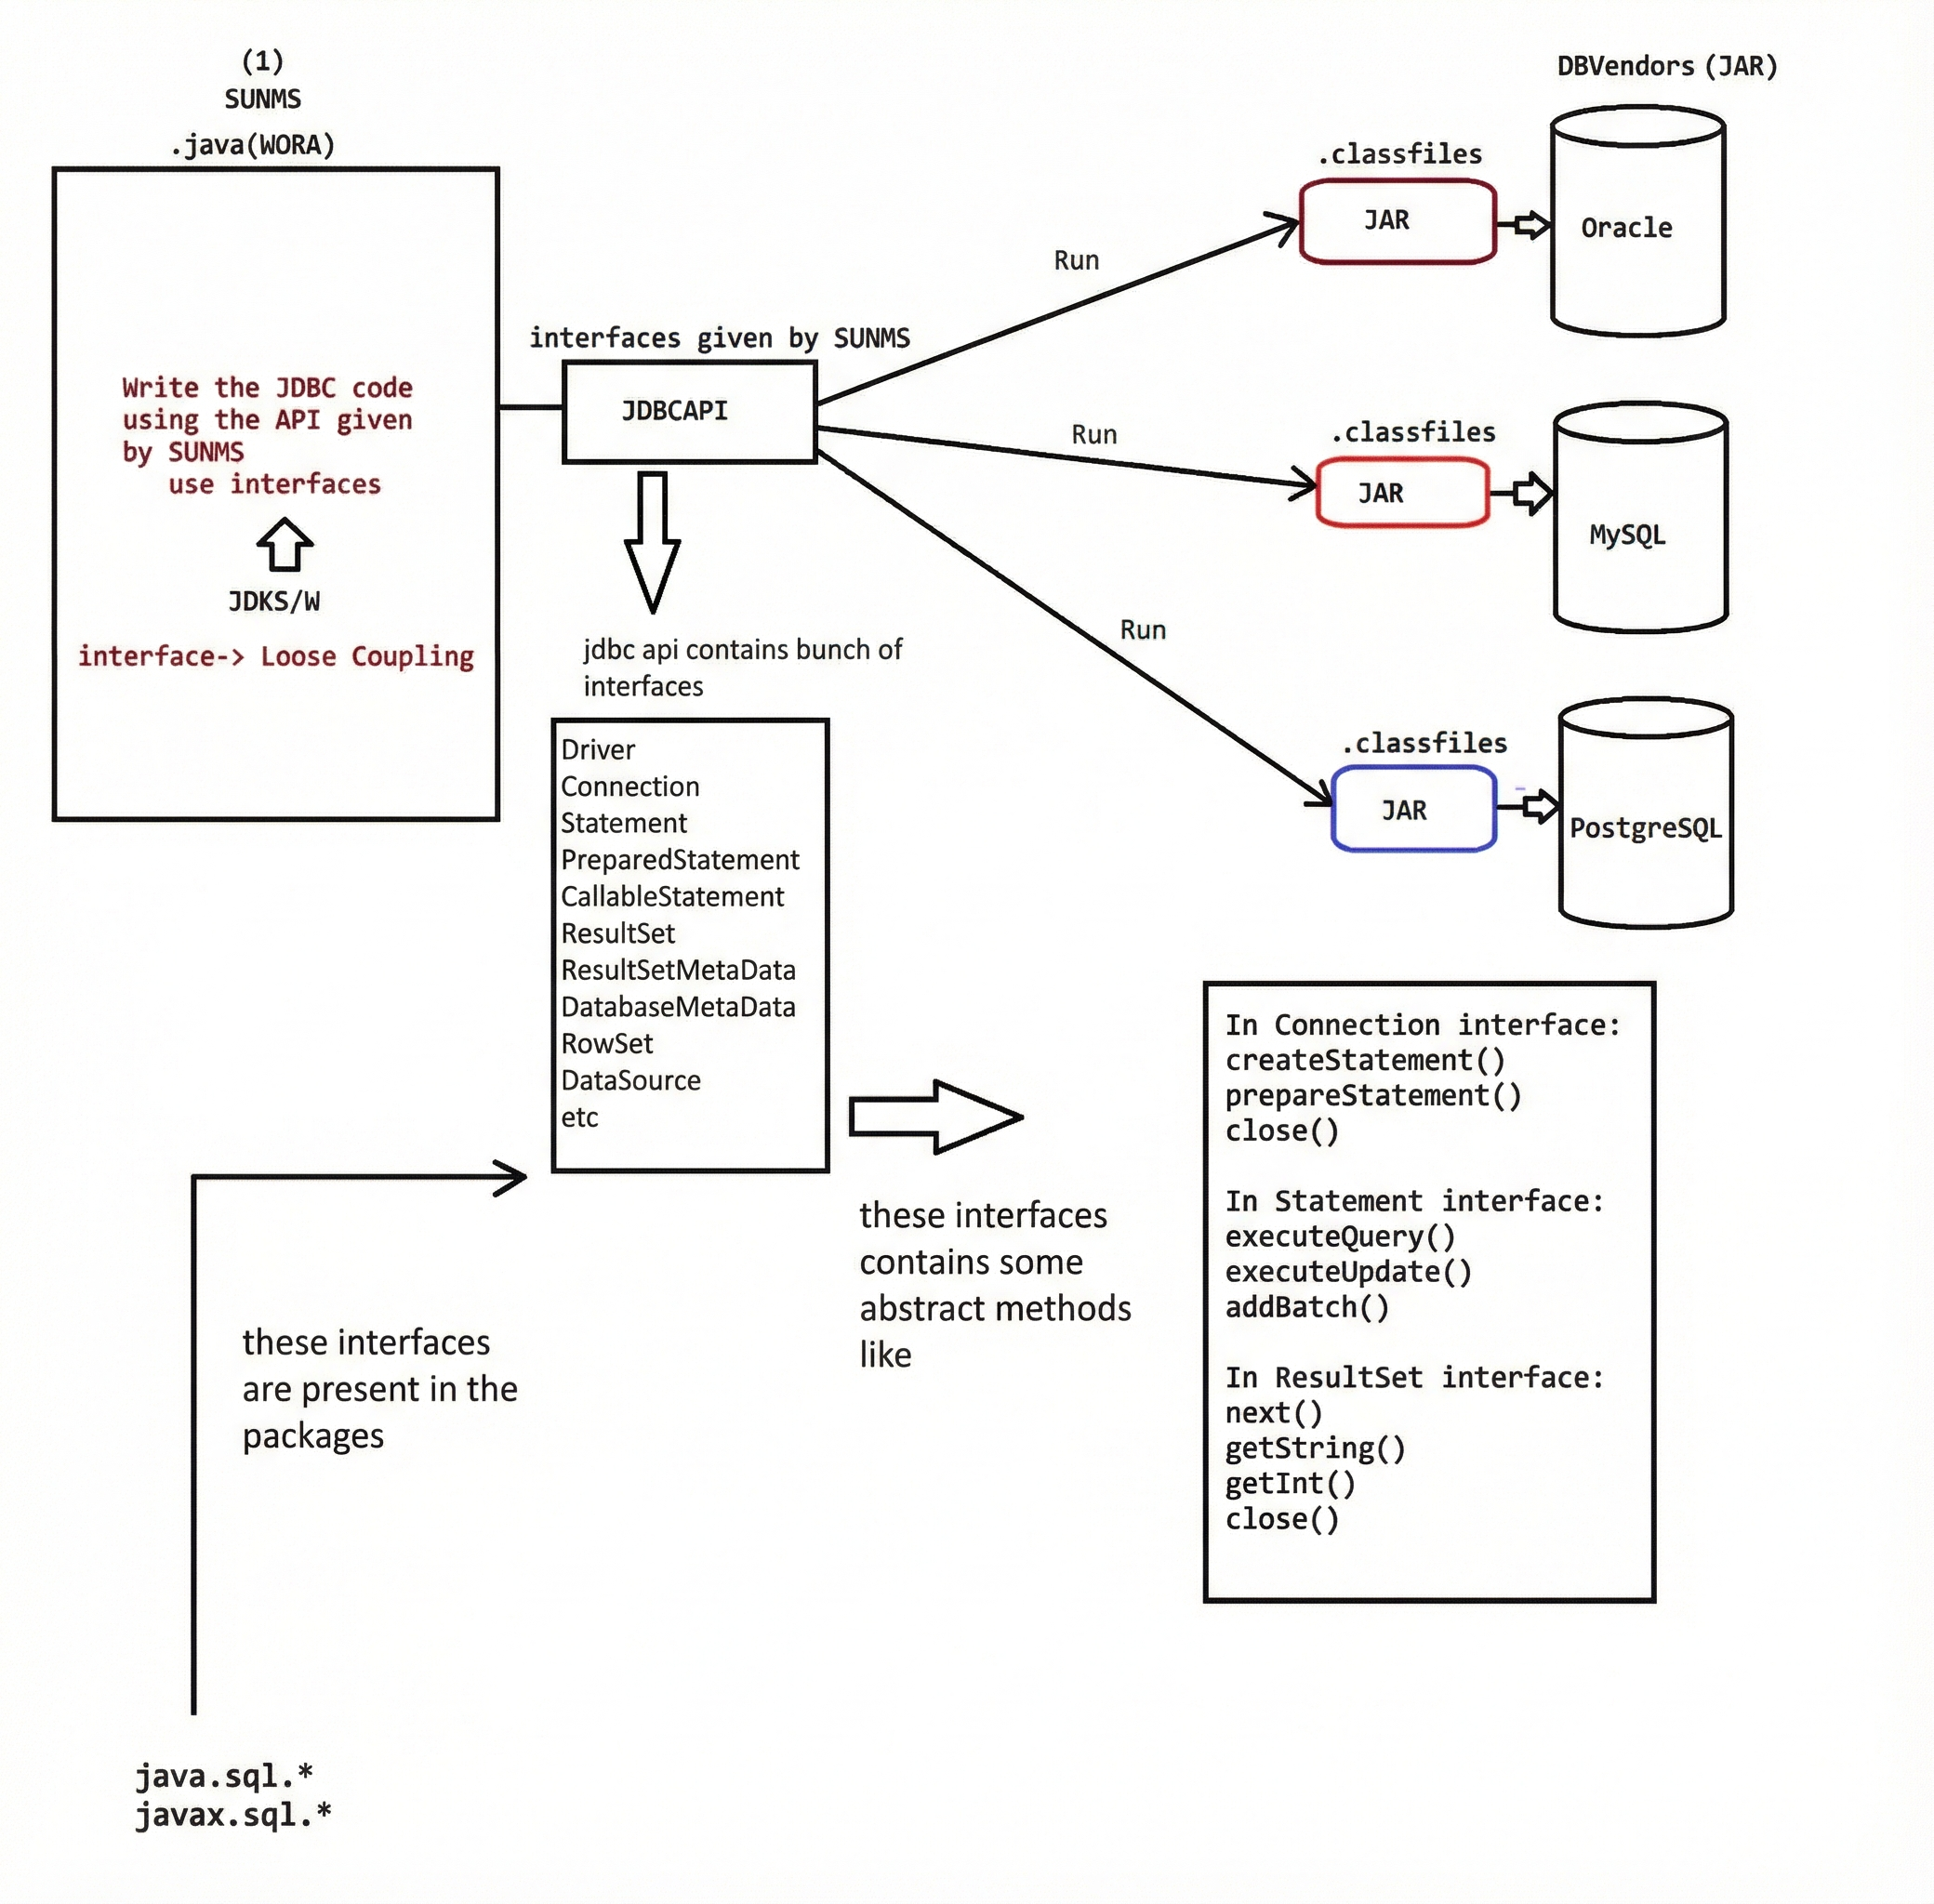

🌟 JDBC: How Java Talks to a Database (Very Simple Explanation)
Imagine you (Java program) want to talk to an Oracle/MySQL database.
But Java cannot speak "database language" directly.
So Java needs:
1️⃣ A translator → Driver
2️⃣ A phone connection → Connection
3️⃣ A way to send questions → Statement
4️⃣ A way to read answers → ResultSet
SUN Microsystems (Java) defined 6 JDBC steps.

✅ STEP 1 → Load & Register Database Driver

❓ Why do we need a Driver?
Because Java does not understand Oracle or MySQL’s language.
So every database company must provide a Driver class that teaches Java how to talk to their database.
Example:
Company | Driver class
Oracle | oracle.jdbc.driver.OracleDriver
MySQL | com.mysql.cj.jdbc.Driver
This driver behaves like a translator between Java and the database.

🖼️ How Driver and OracleDriver relate
The image you shared is showing this concept:
Driver (Interface) ← Given by SUN Microsystems (Java)
↑ implements
OracleDriver (Class) ← Given by Oracle Company
✔ Driver is an interface created by SUN Microsystems
✔ OracleDriver is a class created by Oracle Corporation
✔ OracleDriver implements the Driver interface
This means:
👉 Oracle created a class that follows Java’s rules for JDBC
👉 Therefore Java can use it for database communication

❓ What does “Load the Driver Class” mean?
When we write:
Class.forName("oracle.jdbc.driver.OracleDriver");
We are telling JVM:
👉 "Please load OracleDriver.class into memory."

✔ What happens internally?
Inside OracleDriver class:
static {
OracleDriver driver = new OracleDriver(); // object created
DriverManager.registerDriver(driver); // registered
}
This static block executes AUTOMATICALLY when the class is loaded.

✔ So after loading:
- OracleDriver object is created
- DriverManager registers it
- Now Java knows how to talk to Oracle

Understanding the driver structure

Step-1🌟 The META-INF/services/java.sql.Driver File
Inside every JDBC driver JAR, there is a folder:
META-INF/services/
Inside it, there is a file named:
java.sql.Driver
⚠ IMPORTANT
This file name is always the same in every JDBC driver:
- MySQL driver JAR → has java.sql.Driver
- Oracle driver JAR → has java.sql.Driver
- PostgreSQL driver JAR → has java.sql.Driver
The name never changes because Java expects this exact file.

✔ What type of file is this?
It is NOT a Java file.
It is NOT a class file.
It is NOT an XML or JSON file.
It is simply:
👉 A plain text file
You can open it with Notepad.

✔ What does the file contain?
It contains one line:

Example (Oracle driver):
oracle.jdbc.driver.OracleDriver

Example (MySQL driver):
com.mysql.cj.jdbc.Driver
This line is just text telling Java:
👉 "This is the driver class inside this JAR."
That's it.
No code.
No methods.
Just the driver class name.

❤️ SIMPLE EXPLANATION:
The file is like a name tag inside the JAR.
Java looks at it and says:
“Oh, this JAR contains a driver class called
oracle.jdbc.driver.OracleDriver.”
This is how Java knows which class to load automatically.

🌟 STEP 2 — The Actual Driver Class (Deep Explanation)
Now look at the second part of the folder structure:
oracle/
jdbc/
driver/
OracleDriver.class
This is the real Oracle JDBC driver class.

✔ Who created this class?
👉 Oracle Corporation (not SUN/Java)

✔ What does this class do?
It implements the interface:
java.sql.Driver
This interface is created by SUN Microsystems and defines the rules for JDBC drivers.
So OracleDriver looks like this conceptually:
public class OracleDriver implements java.sql.Driver {
static {
DriverManager.registerDriver(new OracleDriver());
}

// driver methods implementation...
}

❤️ Key Points to Understand:

✔ 1. The file in META-INF only mentions the class name
It does not contain the class itself.

✔ 2. The real class (OracleDriver.class) is stored outside META-INF
Inside its actual package structure:
oracle/jdbc/driver/OracleDriver.class

✔ 3. This class contains a static block
This block runs when the class loads.
static {
DriverManager.registerDriver(new OracleDriver());
}

✔ 4. Static block automatically registers the driver
So Java does not need you to manually register it.

⭐ Putting It Together (Beautiful Understanding)

🔹 The text file (java.sql.Driver)
Tells Java which driver class to load.

🔹 The actual class (OracleDriver.class)
Implements the logic and registers itself when loaded.

🔹 Java uses SPI (Service Provider Mechanism)
To connect these two things.

✔ Java sees the text file

✔ Reads the driver class name

✔ Loads that driver class

✔ Static block registers the driver
Everything happens automatically without writing:
Class.forName("oracle.jdbc.driver.OracleDriver");

❤️ FINAL SUPER SIMPLE SENTENCE
The text file inside META-INF tells Java which driver class to load, and the actual driver class (outside META-INF) registers itself when Java loads it.

